For the purpose of escaping expenses, the electromagnetic shielding of CPC card phenomenon, based on the understanding of the classical theory of electromagnetic shielding, using the two-way communication characteristics of CPC card and RSU, gives a comprehensive response to the artificial electromagnetic shielding of RSU recognition CPC card Strategy. In the scheme, considering the power consumption problem in the system application process,

a solution for setting the transverse vibration marking line with the joint vibration sensor and RSU is proposed.

When the system works, the roadside unit RSU communicates with the composite pass card in a one-way communication or two-way communication mode. If it is a one-way communication mode, the composite pass card is always in the sleep state, and the RSU is set along the highway. The transmitted broadcast modulation signal can wake up the composite pass card, and the composite pass card records the path information transmitted by the RSU by receiving the induced current generated by the signal; if it is the two-way communication mode, the composite pass card is in the working open state when adjacent to the roadside unit RSU. After receiving the RSU monitoring signal, that is, the path information, the response signal is sent as a response, thereby realizing the collection of the composite pass card information.

However, if the driver intentionally places the composite passer in a closed metal container while driving, in order to achieve the purpose of escaping, the composite access will place the card in an electromagnetic shielding state. For a one-way communication type composite pass card, the broadcast signal that causes the RSU to transmit cannot wake up the composite pass card, and the composite pass cannot record the path information of the vehicle; for the two-way communication type composite pass card, the RSU cannot be received The transmitted monitoring signal cannot record the path information of the vehicle, and does not transmit the ID information and the like carried in the signal transmitted by itself to the RSU. Therefore, this method of applying electromagnetic shielding to the composite pass card reduces the reliability of the ambiguous path identification system and poses a threat to the legitimate interests of the highway owners.

Assume that the two-way composite pass card maintains the transmitting state. If the RSU receives the ID information transmitted by the active bidirectional composite pass card, it transmits a response signal. **If the CPC card is not in the shielded state, it receives the RSU response signal and then transmits a response to the RSU. The signal indicates that the RSU path information has been received**

if the **CPC card is placed in a closed metal container**, according to the mirror electromagnetic field theory, the electric field generated by the CPC card will generate a reverse electric field at **a symmetrical position** outside each metal plane, and **multiple** reverse electric fields. When superimposed on each other**, the RSU can receive the signal transmitted by the CPC card; so the CPC card will not be able to Receiving the response signal of the RSU，therefore, if the RSU does not receive the response signal from the active bidirectional composite pass,**

Successful Downloading database file from Dropbox, overwriting C:\FINAL_PROJECT\EBIKE_Files\Data.db…

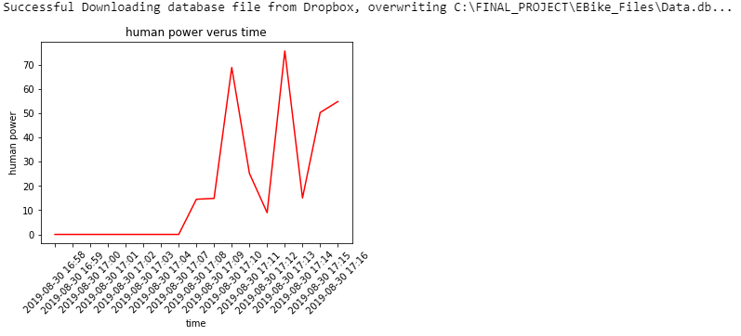

Successful Downloading /Apps/E4Link/IBI/IBIData2019-08-30-17-05.txt from Dropbox, overwriting C:\FINAL_PROJECT\IBI_Files\IBIData2019-08-30-17-05.txt…

